ECPHRASTIC POETRY ACTIVITY
MUSIC

Using the given stimulus material, create the following types of poetry:
- Free verse
- Acrostic
- Cinquain
- Haiku
- Limerick
Remember to complete the following steps:
- View a stimulus image and identify a music-related concept it evokes.

- If required, write down the concept, definition, law, formula etc.

- Identify a suitable poetry type and write the poem.

STIMULUS IMAGE 1
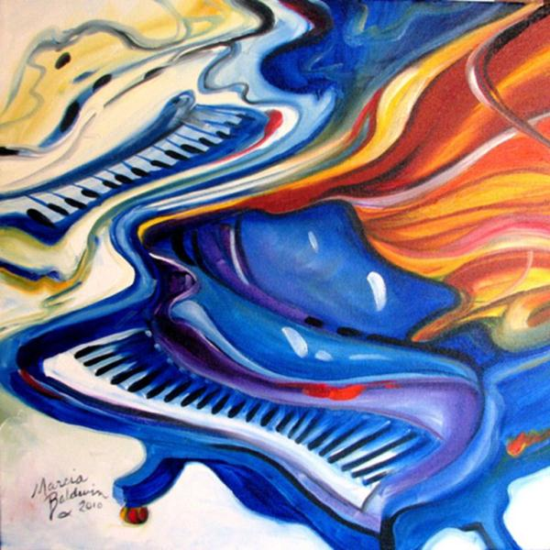
http://marciabaldwin.artspan.com/show-image/1037366/Marcia-Baldwin/JAZZ-PIANOS-GRAND-16x16-ORIGINAL-OIL-PAINTING-ABSTRACT-MUSIC-SERIES-by-M-BALDWIN.jpg

STIMULUS IMAGE 2
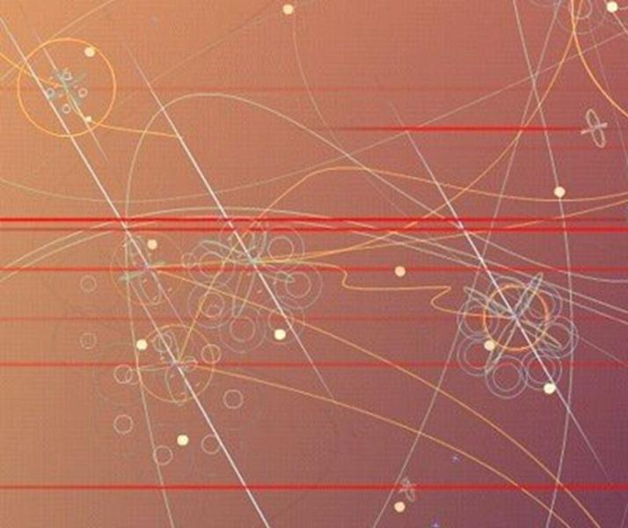
http://ursispaltenstein.ch/blog/images/uploads_img/visual_acoustics_.jpg

STIMULUS IMAGE 3
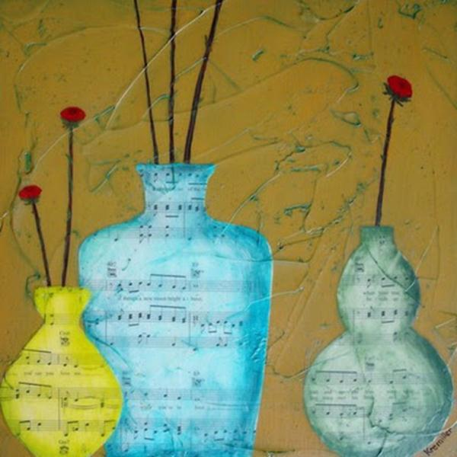
http://2.bp.blogspot.com/_jWTi8RTSXfk/R698k3XtFUI/AAAAAAAAASk/aAtjqHkltms/s400/three+vases+painting.jpg
STIMULUS IMAGE 4
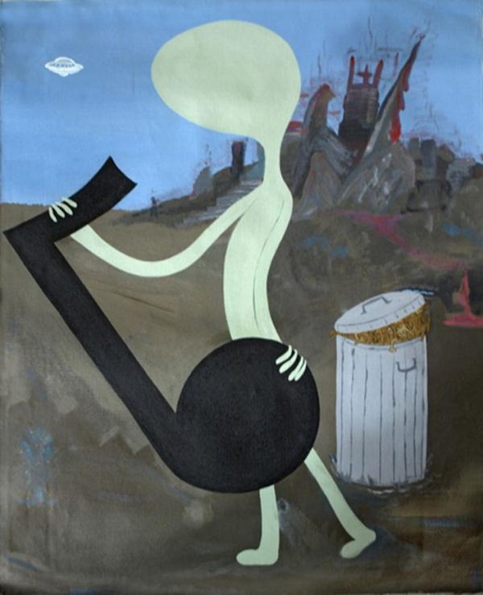
http://www.well.com/~hendrix/paintings/AlienMusicPainting.jpg

STIMULUS IMAGE 5
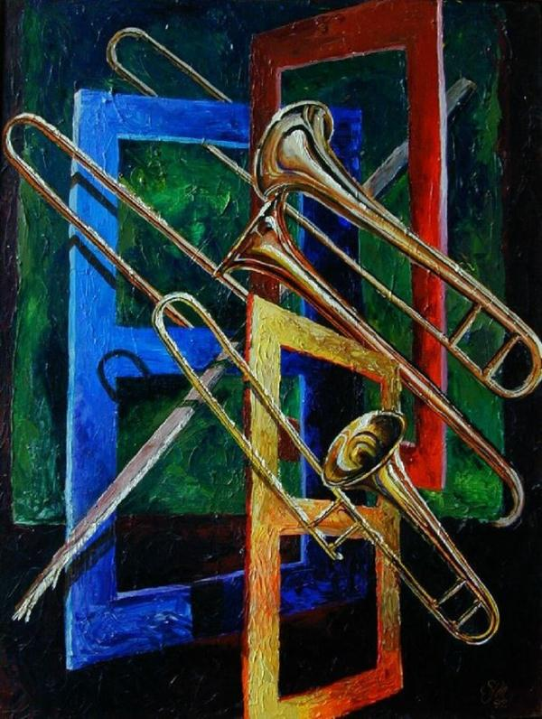
http://tromboneforum.org/gallery/7478_09_07_07_1_20_47.jpg

